Update monthly OS Image in SNOW

Go to 'atapcustomimagesvhdstore' storage account in ATA production & if a customer requests to upload an image, then we ensure that there is a container in Blob storage for the respective customer and upload the vhd file there using Storage explorer or az copy cmdlets.

Also check With AST if new request has been raised for this task if not you can close Monthly change with that update.

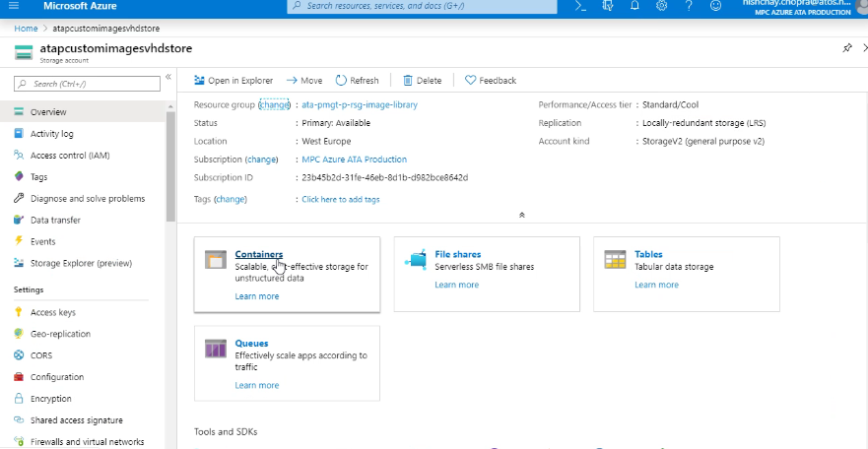

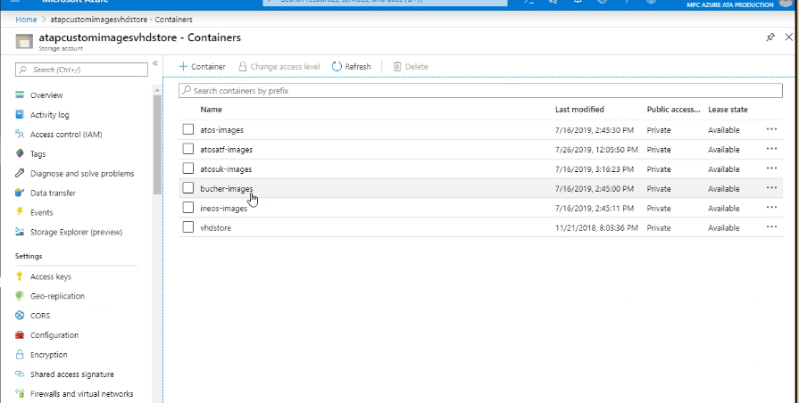

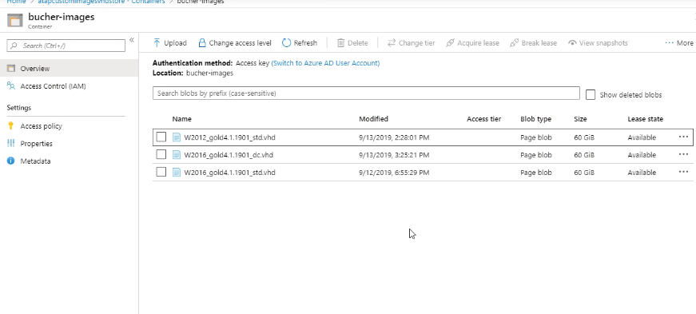

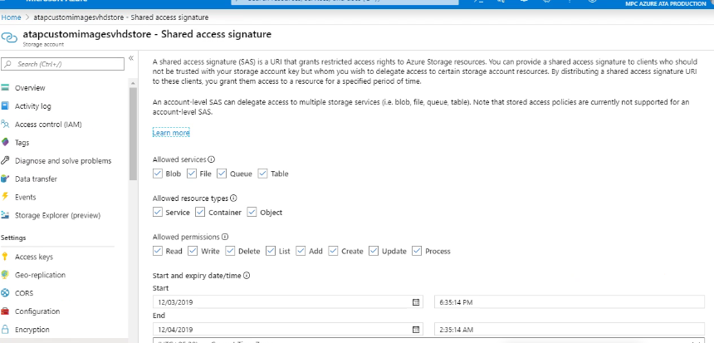

https://azure.microsoft.com/en-in/features/storage-explorer/

